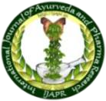**ISSN: 2322 - 0910 (O)**

International Journal of Ayurveda and Pharma Research

**Research Article**

***HARIDRADI GANA KWATHA* IN THE MANAGEMENT OF *STANYA KSHAYA* W.S.R TO HYPOGALACTIA - A CLINICAL STUDY**

**Apila Nath M.K1*, N.Sudhakar2, Sarojini Byadagi3, Binu.M.B4**

*1PG Scholar, 2Professor & HOD, Dept. of Prasutitantra and Stree Roga, 3Professor, Dept. of Dravyaguna, S.G.V Ayurvedic Medical College, Bailahongal, Belagavi District, Karnataka, India.

4PG Scholar, Dept. of Rasashastra, Bhaishjya Kalpana Ramakrishna Ayurvedic Medical College Hospital & Research Centre, Bengaluru, India.

# ABSTRACT

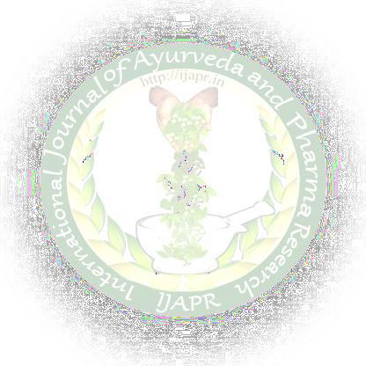*Stanya Kshaya* is a common threat, especially with primiparous women and the incidence had been estimated to range from 23% to 63% during the first 4 months after delivery. Emotional stress, anxiety and maternal illness are the various psychosomatic factors that influence the production of milk. A total 30 patients who fulfilled the inclusion criteria were selected randomly selected. *Haridradi Gana Kwatha*, 48ml, two times a day, after food for a period of 30 days was given. They were followed up every 10th day for 40 days after intervention. Initially all were noted and changes in signs and symptoms in each follow up were observed and noted. Comparing all parameters, before treatment and after treatment the study revealed extremely statistically significant. *Haridradi Gana kwatha* has promising results in the management of all the parameters of *Stanya Kshaya*. *Haridradi Gana kwatha* has promising results in the management of all the parameters of *Stanya Kshaya. Mandagni* serving as *Nidana* of all diseases is corrected by the judicial usage of drugs which are having *Deepaniya Pachana Guna*. The correction of *Atisantarpana* leads to normalisation of *Vata* also. Hence the *Preenana* from the diet is assimilated properly by the *Jatharagni.*

**KEYWORDS:** *Haridradi Ganakwatha, Stanya Kshaya,* Hypogalactia, *Jatharagni.*

# INTRODUCTION

Breast milk is the unique ideal species specific composition for nourishment of infants up to 4-6 months of life. It offers the best balance of nutrients such as proteins, carbohydrates, fats, Immunoglobulin IgA, digestive enzymes, minerals, lymphocytes, antibodies and water in right composition to meet the growth and developmental demands of babies in safe, clean, hygienic cheap and correct temperature.[1,2,3]

Adequate lactation has been defined as secretion of 300ml (10 ounces) daily by the 5th day and 480ml (16 ounces) by the 10th day. Also, if the baby is satisfied and sleeping for 2-3 hrs after breast feeding, passing urine 6-8 times in 24 hrs and gaining weight, the mother is producing enough milk. If these amounts are not achieved, a baby of normal weight will not be adequately fed and such a situation is termed clinically as Lactational deficiency. It is also defined as the need to start top feeds for the baby within 3 months of delivery. In Asian and Tropical countries like India prevalence of Lactational deficiency may be 30-40% and ranges from 23% to 63% globally. The WHO recommends exclusive

breastfeeding for the first 6 months of life, after which infants should receive nutritionally adequate and safe complementary foods while breastfeeding continues for up to two years of age or beyond.[4]

In Ayurveda, the quality of *Sthanya,* quality of lactating mother, breastfeeding benefits for both mother and child etc are elaborately explained. Causes of *Sthanya Kshaya* are explained by various *Acharyas* like *Charaka, Sushrutha, Vaghbata, Kashyapa,* and *Bhavaprakasha.* According to them *Sthanya Kshaya* occurs due to psycho-somatic factors of mother like *Krodha, Shoka, Bhaya*, etc, diet regimen of mother and physiological condition.[5-9]

In our classics a large number of drugs, diet and behavior regimens are described as *Sthanyajanana* and are useful in the management of *Sthanya Kshaya*. *Acharya Govinda Das Sen* had indicated *Haridradi Gana Kwatha* in *Sthanya Vridd*i in *Bhaishajya Ratnavali Sthana Roga Adhyaya*[10]. The present study aims at literary description of *Sthanya Kshaya* and probable mode of action and efficacy of *Haridradi Gana Kwatha* based upon pharmacological properties and chemical composition[11].

# MATERIALS AND METHODS

30 Patients suffering with Signs and Symptoms of *Sthanya Kshaya* were randomly selected from *Prasuti Tantra and Stri Roga* OPD & IPD of SGV Ayurvedic Medical College Hospital, Bailhongal.

|  |  |
| --- | --- |
| **Inclusion criteria** | **Exclusion criteria** |
| Age group of patients in between 18-35 yrs. | Patients with Congenital anomalies, Breast atrophy, Cancers, Mastitis, Shock, Previous menstrual disorders will be excluded from study |
| Patients from 5th day of delivery till 6th month of delivery. | Patients having h/o Alcoholism, Infections & Systemic diseases. |
| Patients with previous history of Hypogalactia. | Post partum hypopituitarism |
| Breast feeding frequency less than 4-5 times /day. | Post partum haemorrhage |
| Patients either of Primigravida or Multigravidae will be selected |  |

# Table 2: Subjective Parameter

|  |  |  |
| --- | --- | --- |
| **Parameter** | 1 | 0 |
| *Stana Mlanatha* | Present | Absent |
| *Stana Shuskatha* | Present | Absent |
| *Stanya Alpatha* | Present | Absent |
| *Stanya Asambhavatha* | Present | Absent |
| Residual Milk | Present | Absent |

|  |  |
| --- | --- |
| Feeding 0 to 2 times per day | Grade 3 |
| Feeding 3 to 5 times per day | Grade 2 |
| Feeding 6 to 8 times per day | Grade 1 |
| Feeding >9 times per day | Grade 0 |

|  |  |  |  |  |  |
| --- | --- | --- | --- | --- | --- |
| **Breast milk Ejection** | 0  Forceful | 1  Stream like | 2  Drop by drop | 3  No milk | 4  NA |
| **Breast Engorgement** | 0  Normal | 1  Mild | 2  Moderate | 3  Severe | 4  Very severe |

A Randomized single blind clinical study was done with 30 patients. The duration of the study was 40 days. Treatment duration was 30 days and Follow up was done in every 10th day. The assessment of the subjects was done on 0th day, 10th day, 20th day, 30th day and 40th day.



**Table 3: Breast Feeding Frequency**

**Table 4: Objective Parameter**

Acharya Govinda das sen has described *Haridradi Gana Kwatha* in *Sthana Roga Adhyaya (70/3rd shlogha,* it is also advised for *Stnaya Shodhana*

Required dry drugs for preparing *Haridradi Gana Kwatha* was procured from local market and pharmacy; botanist authenticated it*. Choorna* was prepared as per standard method. And *Haridradi*

*Gana Choorna* given to patients and the method of

*Kwatha* preparation is advised to prepare at home. The ingredients in *Haridradi Gana* are; *Haridra* (*Curcuma longa*), *Daruharidra* (*Berberis aristata*), *Prishniparni* (*Uraria picta*), *Indrayava* (*Holarrhene antidycentrica*), *Yashtimadhu* (*Glycorriza glabra*). All the above drugs are taken in equal quantity. The quantity of *Jala* will be 16 parts to that of drug and is further boiled and reduced to 1/8 parts (ratio of drug: *Jala: Kwatha* is 1:16:2).[11] The study done total duration of 40 days with follow up of every 10th day and assessment of study was done on 40th day. Pre and post test results were assessed statistically by paired t –test.

# RESULTS

**Table 5: Effect of therapies *Haridradi Gana Kwatha* on Breast appearance (*Stana Mlanatha*/*Sthana Sushkatha*)**

|  |  |  |  |  |  |  |  |  |  |
| --- | --- | --- | --- | --- | --- | --- | --- | --- | --- |
| Breast appearance | **Mean score** | | | **%** | **S.D (±)** | **S.E (±)** | **t value** | **P**  **Value** | **Remarks** |
| **BT** | **AT** | **BT-AT** |
| 0.8 | 0.2 | 0.67 | 76.7 | 0.48 | 0.088 | 7.6158 | <0.0001 | Extremely significant |

Effect of *Haridradi Gana Kwatha* on Breast appearance (*Stana Mlanatha*/*Stana Shushkatha*)- Severity of mean score before treatment was 0.866 which was reduced to 0.2 after treatment with 76.7% relief. The total effect of therapy provided with extremely statistically significant (“p” value< 0.0001) result with t value of 7.6158.

**Table 6: Effect of therapies *Haridradi Gana Kwatha* on Breast milk quantity (*Stanya Asambavata/Stanya Alpata)***

|  |  |  |  |  |  |  |  |  |  |
| --- | --- | --- | --- | --- | --- | --- | --- | --- | --- |
| Breast milk quantity | **Mean score** | | | **%** | **S.D (±)** | **S.E (±)** | **t value** | **P**  **Value** | **Remarks** |
| **BT** | **AT** | **BT-AT** |
| 1 | 0.16 | 0.834 | 83.4 | 0.38 | 0.07 | 12.041 | <0.0001 | Extremely significant |

Effect of *Haridradi Gana Kwatha* Breast milk quantity (*Stanyaasambavata*/*Stanyaalpata*)- Severity of mean score before treatment was 1 which was reduced to 0.16 after treatment with 83.4% relief. The total effect of therapy provided with extremely statistically significant (“p” value <0.0001) result with t value of 12.041.

**Table 7: Effect of therapies *Haridradi Gana Kwatha* on Breast feeding frequency**

|  |  |  |  |  |  |  |  |  |  |
| --- | --- | --- | --- | --- | --- | --- | --- | --- | --- |
| Breast feeding frequency | **Mean score** | | | **%** | **S.D (±)** | **S.E (±)** | **t value** | **P**  **Value** | **Remarks** |
| **BT** | **AT** | **BT-AT** |
| 1.96 | 0.43 | 1.53 | 78.06 | 0.57 | 0.1 | 14.6993 | <0.001 | Extremely significant |

Effect of *Haridradi Ghana Kwatha* on Breast feeding frequency- Severity of mean score before treatment was 1.96 which was reduced to 0.43 after treatment with 78.06% relief. The total effect of therapy provided with extremely statistically significant (“p” value <0.001) result with t value of 14.6993.

**Table 8: Effect of therapies *Haridradi Gana Kwatha* on residual milk**

|  |  |  |  |  |  |  |  |  |  |
| --- | --- | --- | --- | --- | --- | --- | --- | --- | --- |
| Residual milk | **Mean score** | | | **%** | **S.D (±)** | **S.E (±)** | **t value** | **P**  **Value** | **Remarks** |
| **BT** | **AT** | **BT-AT** |
| 0.166 | 0.033 | 0.133 | 80.12 | 0.35 | 0.06 | 2.112 | <0.001 | Statistically significant |

Effect of *Haridradi Gana Kwatha* on residual milk- Severity of mean score before treatment was 0.166 which was reduced to 0.033 after treatment with 80.12% relief. The total effect of therapy provided with statistically significant (“p” value <0.001) result with t value of 2.112.

**Table 9: Effect of therapies *Haridradi Gana Kwatha* on Breast milk ejection**

|  |  |  |  |  |  |  |  |  |  |
| --- | --- | --- | --- | --- | --- | --- | --- | --- | --- |
| Breast milk ejection | **Mean score** | | | **%** | **S.D (±)** | **S.E (±)** | **t value** | **P**  **Value** | **Remarks** |
| **BT** | **AT** | **BT-AT** |
| 1.76 | 0.5 | 1.26 | 71.59 | 0.52 | 0.10 | 13.32 | <0.001 | Extremely significant |

Effect of *Haridradi Gana Kwatha* on Breast milk ejection- Severity of mean score before treatment was

1.76 which was reduced to 1.26 after treatment with 71.59% relief. The total effect of therapy provided with statistically extremely significant (“p” value <0.001) result with t value of 13.32.

**Table 10: Effect of therapies *Haridradi Gana Kwatha* on Breast engorgement**

|  |  |  |  |  |  |  |  |  |  |
| --- | --- | --- | --- | --- | --- | --- | --- | --- | --- |
| Breast engorgement | **Mean score** | | | **%** | **S.D (±)** | **S.E (±)** | **t value** | **P**  **Value** | **Remarks** |
| **BT** | **AT** | **BT-AT** |
| 1.66 | 0.13 | 1.527 | 91.98 | 0.86 | 0.16 | 9.76 | <0.001 | Extremely significant |

Effect of *Haridradi Gana Kwatha* on Breast engorgement- Severity of mean score before treatment was 1.66 which was reduced to 0.133 after treatment with 91.98% relief. The total effect of therapy provided with extremely statistically significant (“p” value <0.001) result with t value of 9.76.

# DISCUSSION

*Stanya* and *Artava* are *Upadhatus* of *Rasa*. By definition, *Upadhatus* are those which get nourished by corresponding *Dhatu* and they do not nourish other entities. For the present study *Haridradi Gana Kashaya* has been used. There are five ingredients in this *Gana*; namely *Haridra, Daruharidra, Prishniparni, Yashtimadhu* and *Indrayava*.

*Kashaya* was prepared as per the classical instructions from *Kashaya Kalpana Adyaya* of *Sharangadhara Samhitha.* Hence the potency of the medication was delivered in its purest form.

*Aushada Sevana Kala* was also decided as per *Bhaishajya Vyakhyana Adyaya* of *Sharangadhara Samhitha.* Hence ‘*Bhojanantha Aushada Sevana’* was decided as *Vyana Kopa* has to be corrected. In *Stanya Kshaya* due to *Pramana Alpatha* and *Srotorodha* the disease manifests. Hence by correcting and strengthening *Vyana Vata* proper separation of nutrients and waste products occurs, resulting in supply of nutrients to all body parts or *Utharothara Dhatu Poshana* and *Upadhatu Nirmana.*

*Haridradi Gana* is a perfect combination of drugs which can clear *Agnimandya* and do *Sroto shodhana* as the majority of the drugs are *Laghu* in *Paka* and *Ushna Veerya.* The very next step in *Samprapthi Vighatana* is providing *Preenana* and *Poshana. Haridradi Gana* is having drugs like *Prishniparni* and *Yashtimadhu* which are *Madhura Vipaka* which does the latter function. *Usna Veerya Katu Vipaka* drugs are known for *Srotoshodhana, Agni Vardhana, Ama Pachana, Vatanulomana.* These attributes helps in clearing the *Sroto Sanga,* followed by *Jataragni* and *Rasa Dhatwagni Vardhana* which in turn helps in *Rasa dhatu and its Upadhatu Nirmana* and *Poshana. Usna Veerya Katu Vipaka* drugs may have hormone stimulating action. *Yashtimadhu* relives deep rooted stress. It is one such drug that can act on *Manasika Bhava* and is a *Medhya Rasayana.* It is having *Madhura Rasa, Sheeta Virya*

and *Madhura Vipaka.* These attributes are similar with *Stanya*. Hence it can help in *Rasa* and *Stanya Vriddhi.* Another main concern after delivery is the reduction of overweight which got put on during the pregnancy. As most of the Herbal Galactogogues available in market are *Madhura Rasa Pradhana* and *Brihmana* in nature it is essential to find a better substitute. Fat deposits acts as a energy reserve to be used during breast feeding. But lactational insufficiency or Hypogalactia left as such. Hence the choice of drugs must be of *Deepana– Pachana Karma* in the former stages. *Haridradi Gana* works well in this scenario.

Effect of therapy on different subjective parameters show significant result. Results in main parameters are as follows. Breast Appearance, Breast Milk Quantity, Breast Feeding Frequency and Breast Milk Quantity have total effect of therapy provided with extremely statistically significant result with t value. Residual Milk, Breast Milk Ejection and Breast Engorgement had also shown positive changes within 40 days. There is effect of *Haridradi Gana Kwatha in* the management of *Sthanya Kshaya* is hence proved.

# CONCLUSION

The present study entitled, “Efficacy of *Haridrardi Gana Kwatha* In The Management Of *Stanya Kshaya* w.s.r. to Hypogalactia- A Single Blind Clinical Study” was carried out on 30 patient of *Stanya Kshaya*. The treatment was evaluated statistically by student “paired t test” to compare the mean values within the group. An attempt was made in this study to evaluate the efficacy of *Haridradi Gana Kwatha* in *Stanya Kshaya*. From the result it can be concluded that patients has showed extremely statistically significant results with regards to improvement of chief complaints like Breast appearance, Breast milk quantity, Breast feeding frequency, Breast milk ejection, Breast engorgement.

Overall study concludes that *Stanya Kshaya* can be managed effectively and safely by *Stanya Janana* and *Stanya Vardhaka Dravyas*. In addition to this, these *Dravyas* can be used in healthy lactating mothers also to enhance breast milk production in a safer way and regain body strength especially in *Sutika Avastha*. No adverse effects were observed during the course of this study.

# Pictures of Experimental Study

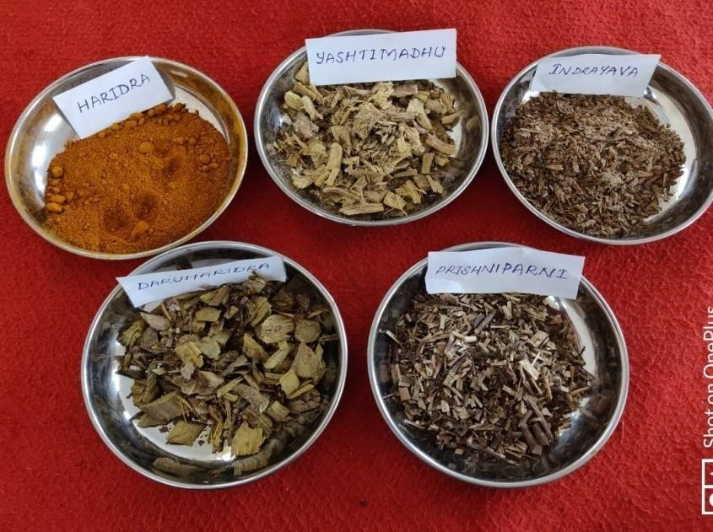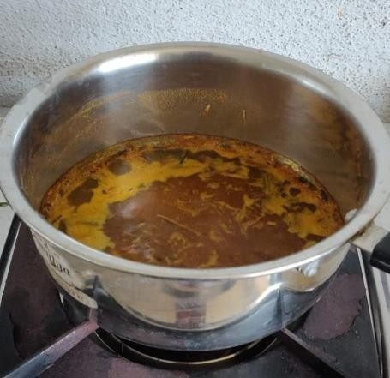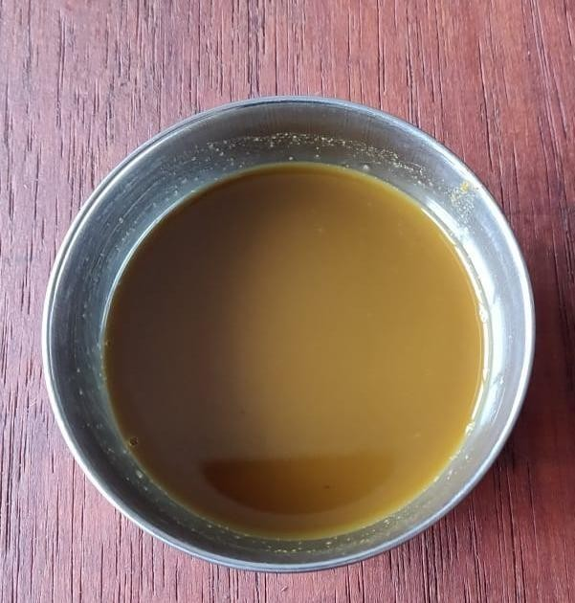

**Image 1: Ingredients of *Haridradi Gana***

**Image 2: Preparation of *Haridradi Gana Kwatha* Image 3: *Haridradi Gana Kwatha***

# REFERENCES

1. O.P. Ghai, Ghai Essential pediatrics, edited by Vinod K Paul and Aravind Bagga, CBS Publishers and Distributers, 8th Edition, Pg no-150-155.
2. K Park-Park’s Textbook of Preventive and Social Medicine, m/s Banarsidas Bhanot Publishers, 22nd edition, 2013, Pg no 497-500.
3. Arshiya Sultanana, Khaleequr Rahmana, Manjula S M S. Review article on maternal health, clinical update and treatment of lactational insufficiency.

Medical journal of Islamic world academy of sciences 21:1, 19-28,2013,

1. Exclusive breast feeding from 6 months best for babies everywhere; WHO, 15 Jan 2011 available fromhttps[://w](http://www.who.int./mediacentre/news/s)ww[.who.int./mediacentre/news/s](http://www.who.int./mediacentre/news/s) tatements/2011/breastfeeding_20110115/en/
2. Susrutha, Susrutha Samhita, Nibandha sangraha commentary of Sri Dalhanacarya edited by Vaidya Yadavji Trikamji Acharya, Published by

Chaukhamba krishanadas academy, Varanasi, Reprint 2014, Sarirasthana, chapter- 10, verses-

30, pg-391, pp-824.

1. Vrddha Vagbhata, Astanga Sangraha, Inducommentary, edited by Dr.Shivprasad sharma, Published by Chaukhamba Sanskrit series office, Varanasi, Reprint 2012, Uttarasthana, chapter – 1, verses - 23, pg- 630, pp

– 965.

1. Vagbhata, Astanga Hrdaya, Sarvanga sundara commentary of Arunadatta edited by Pt. Hari Sadasiva Sastri Paradakara Bhisagacarya, Published by Chaukhamba surbharati prakashan, Varanasi, Reprint 2014, Uttarasthana, chapter – 1, verses – 17, pg-778, pp-956.
2. Vrddha Jivaka Tantra, Revised Vatsya Kashyapasamhita, edited by Prof. P.V. Tewari with English translation and commentary, Published by Chaukhamba visva bharati, Varanasi, Reprint –2008, Sutra Sthana, Chapter-

19, Verse 18, pg- 12, pp-792.

1. Acharya Bhavamishra, Bhavaprakasha, Dr. Bulususitaram commentary with English translation, Published by Chaukhambha Orientalia, Varanasi, Volume 1, Reprint 2015, Prathama purvakhanda, chapter-4, verse-10, pg- 58,pp-742.
2. Acharya Govinda Das in Bhaishajya Ratnavali, edited by Bhishagratna Shri Brahmashankar Mishra, commented by Shri Kaviraja Ambikadatta Shastri Ayurvedacharya, English translated by Dr, Kanjiv Lochan, translation reviewd by Dr Anand k Chowdary, Varanasi, Choukamba Sanskrit Sansthan, Reprint edition 2009 volume 3rd, Sthana Roga Adyaya-70, Shloka -3, pg no:421.
3. Acharya Sharangadhara, Prof. K. R. Srikanta Murthy, in Sharangadhara Samhita, Varanasi: Choukambha Orientalia, 3rd edition 1997; Madhyama Khanda, Kwatha Kalpana, chapter 2, Shloka 1-3, pg.no 56.



**Cite this article as:**

Apila Nath M.K, N.Sudhakar, Sarojini Byadagi, Binu.M.B. Haridradi Gana Kwatha in The Management of Stanya Kshaya w.s.r to Hypogalactia - A Clinical Study. International Journal of Ayurveda and Pharma Research. 2020;8(Suppl 1):19-24.

***Source of support: Nil, Conflict of interest: None Declared***

**\*Address for correspondence Dr Apilanath MK**

Final year PG Scholar Department of Prasutitantra and Stree Roga,

SNVV Samasthe’s S.G.V Ayurvedic Medical College Hospital and Research Centre, Bailahongal, Belgavi, Karnataka.

Email: [mkapilanath@gmail.com](mailto:mkapilanath@gmail.com) Mobile Number: 8217042231

Disclaimer: IJAPR is solely owned by Mahadev Publications - dedicated to publish quality research, while every effort has been taken to verify the accuracy of the content published in our Journal. IJAPR cannot accept any responsibility or liability for the articles content which are published. The views expressed in articles by our contributing authors are not necessarily those of IJAPR editor or editorial board members.